**REACT 06**

**AIM:**

Cognizant Academy teams want to maintain a list of trainers along with their expertise in a SPA using React as the technology. You are assigned the task of creating this React app.

The following trainers’ data application will deal.

1. T-ID
2. Name
3. Phone
4. Email
5. Stream
6. Skills

Create a new React app using *create-react-app* tool with the as “TrainersApp”

**PROGRAM:**

**TRAINER.js:**

export default class Trainer {

  constructor(id, name, phone, email, stream, skills) {

    this.id = id;

    this.name = name;

    this.phone = phone;

    this.email = email;

    this.stream = stream;

    this.skills = skills;

  }

}

**TrainerList.js:**

import React from 'react';

import { Link } from 'react-router-dom';

import './styles/portal.css';

function TrainerList({ data }) {

  return (

    <div className="page">

      <h2>👨‍🏫 Meet Our Trainers</h2>

      <ul className="trainer-list">

        {data.map((trainer) => (

          <li key={trainer.id}>

            <Link to={`/trainer/${trainer.id}`}>{trainer.name}</Link>

          </li>

        ))}

      </ul>

    </div>

  );

}

export default TrainerList;

**TrainerDetails.js:**

import React from 'react';

import { useParams } from 'react-router-dom';

import trainers from './TrainersMock';

import './styles/portal.css';

function TrainerDetails() {

  const { id } = useParams();

  const trainer = trainers.find((t) => t.id === parseInt(id));

  if (!trainer) {

    return <div className="page error">Trainer not found.</div>;

  }

  return (

    <div className="page">

      <h2>👤 Trainer Details</h2>

      <div className="trainer-card">

        <p><strong>Name:</strong> {trainer.name}</p>

        <p><strong>Email:</strong> {trainer.email}</p>

        <p><strong>Phone:</strong> {trainer.phone}</p>

        <p><strong>Stream:</strong> {trainer.stream}</p>

        <p><strong>Skills:</strong> {trainer.skills}</p>

      </div>

    </div>

  );

}

export default TrainerDetails;

**TrainerMock.js:**

import Trainer from './Trainer';

const trainers = [

  new Trainer(1, 'Deepika ', '9876543210', 'deepika@cognizant.com', 'Frontend', 'React, HTML, CSS'),

  new Trainer(2, 'Meera ', '9123456789', 'meera@cognizant.com', 'Backend', 'Node.js, Express'),

  new Trainer(3, 'Rahul ', '9988776655', 'rahul@cognizant.com', 'DevOps', 'Docker, Jenkins'),

  new Trainer(4, 'Anjali ', '9001234567', 'anjali@cognizant.com', 'Cloud', 'AWS, Azure')

];

export default trainers;

**Home.js:**

import React from 'react';

import './styles/portal.css';

function Home() {

  return (

    <div className="page home">

      <h1>📚 Welcome to TrainersPortal</h1>

      <p>Explore our top trainers and their specializations!</p>

    </div>

  );

}

export default Home;

**App.js:**

import React from 'react';

import { BrowserRouter as Router, Routes, Route, Link } from 'react-router-dom';

import Home from './Home';

import TrainerList from './TrainerList';

import TrainerDetails from './TrainerDetails';

import trainers from './TrainersMock';

import './styles/portal.css';

function App() {

  return (

    <Router>

      <div className="nav">

        <Link to="/">🏠 Home</Link>

        <Link to="/trainers">👨‍🏫 Trainers</Link>

      </div>

      <Routes>

        <Route path="/" element={<Home />} />

        <Route path="/trainers" element={<TrainerList data={trainers} />} />

        <Route path="/trainer/:id" element={<TrainerDetails />} />

      </Routes>

    </Router>

  );

}

export default App;

**portal.css:**

body {

  margin: 0;

  font-family: 'Segoe UI', sans-serif;

  background: linear-gradient(to bottom right, #edf2fb, #d7e3fc);

  color: #333;

}

.nav {

  display: flex;

  background-color: #1976d2;

  padding: 10px 20px;

  gap: 20px;

}

.nav a {

  color: white;

  text-decoration: none;

  font-weight: 600;

}

.nav a:hover {

  text-decoration: underline;

}

.page {

  padding: 30px;

}

h1, h2 {

  color: #2e3c6a;

}

ul.trainer-list {

  list-style: none;

  padding: 0;

}

ul.trainer-list li {

  background: #ffffff;

  margin: 10px 0;

  padding: 12px;

  border-left: 4px solid #1976d2;

  border-radius: 6px;

}

ul.trainer-list li a {

  text-decoration: none;

  color: #1976d2;

  font-weight: 500;

}

ul.trainer-list li a:hover {

  color: #004ba0;

}

.trainer-card {

  background: white;

  padding: 20px;

  border-radius: 8px;

  max-width: 500px;

  box-shadow: 0 4px 12px rgba(0, 0, 0, 0.1);

}

Output 01:

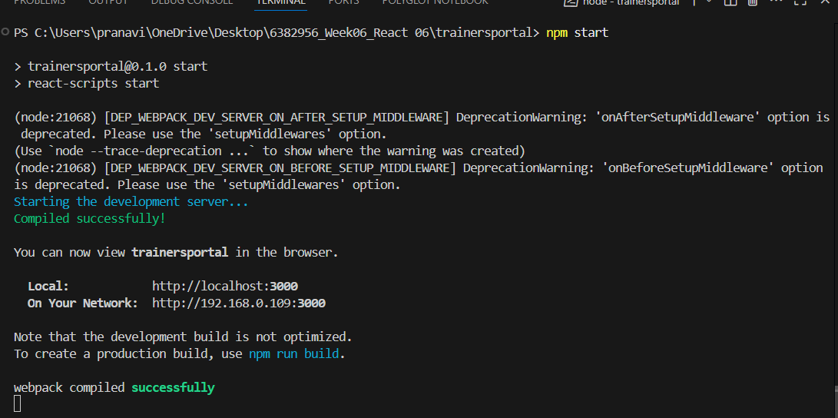

Output 02:

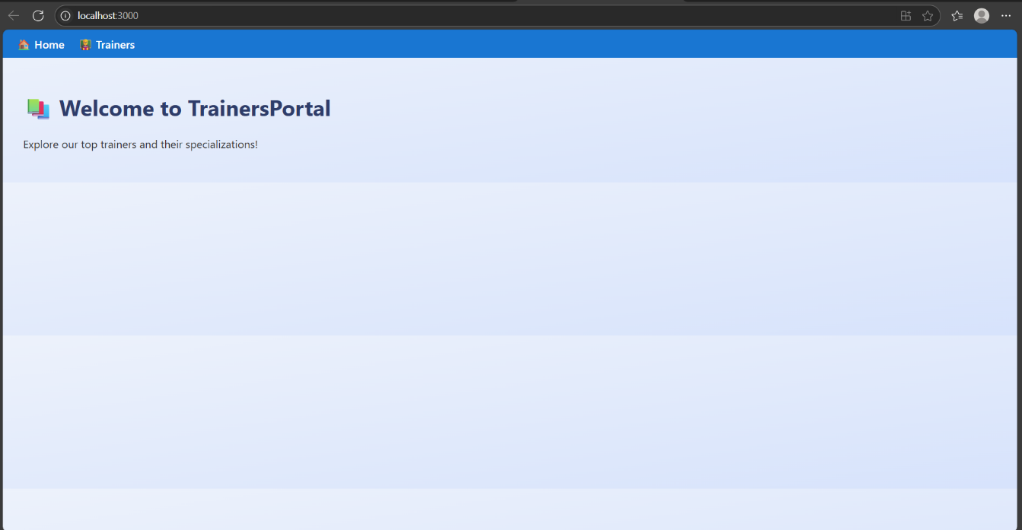

Output 03:

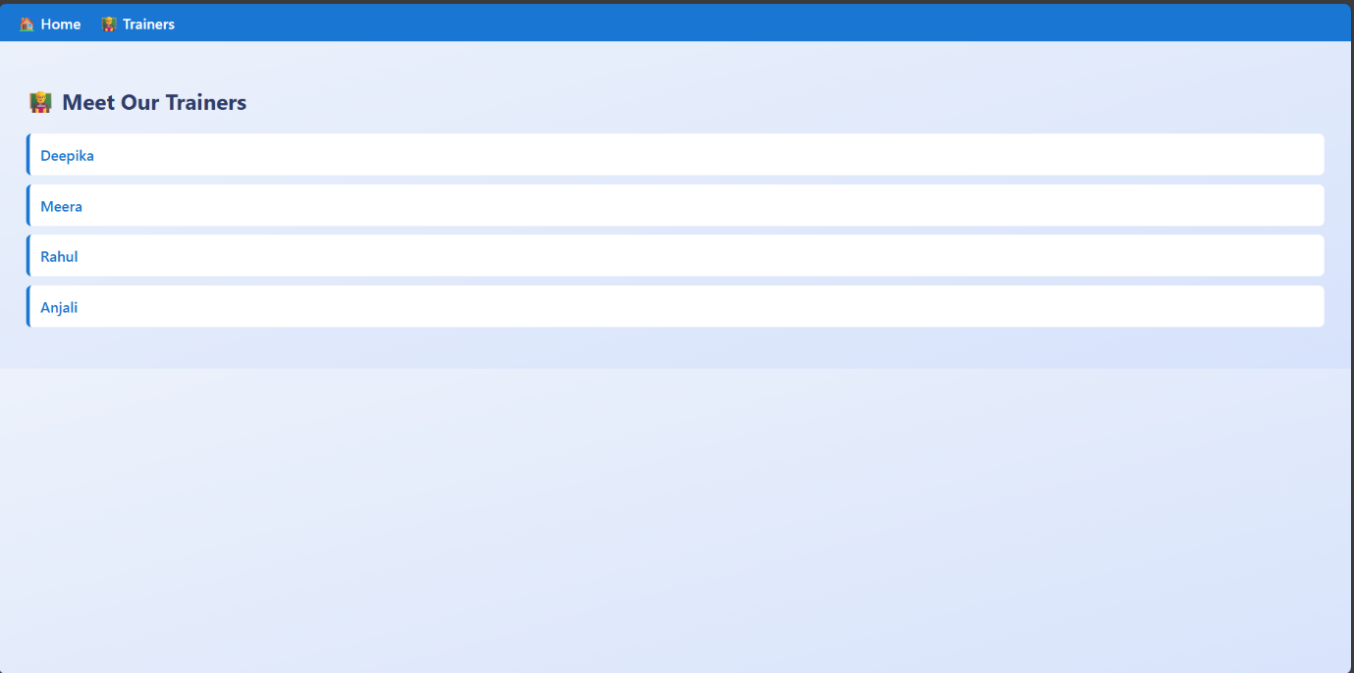

Output 04:

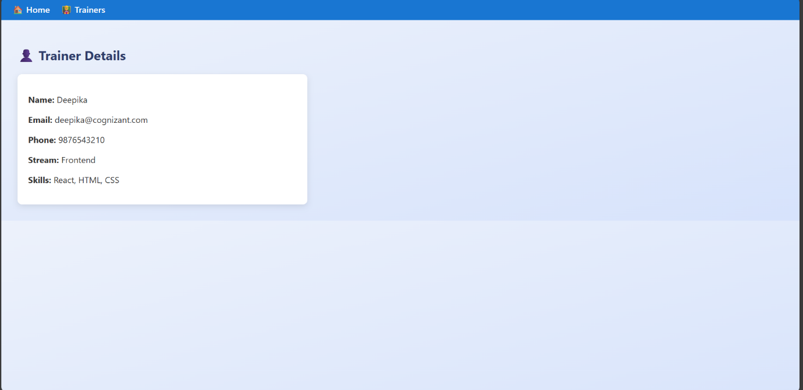

Output 05:

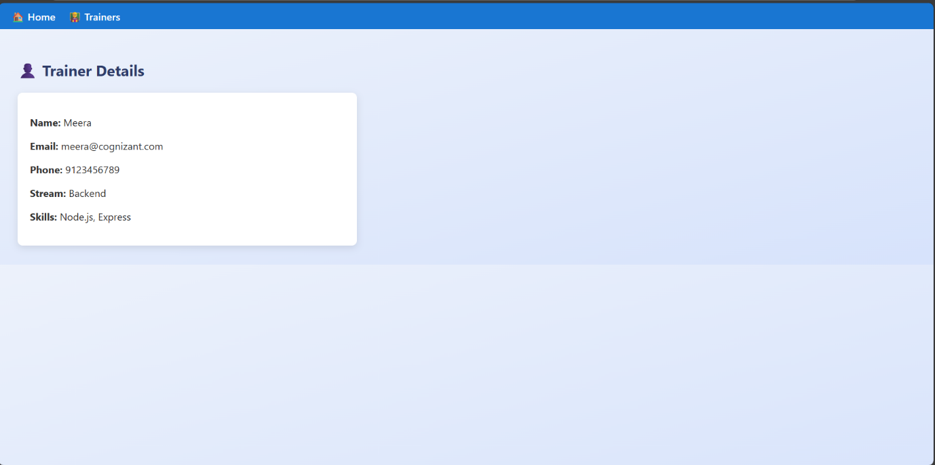

Output 06:

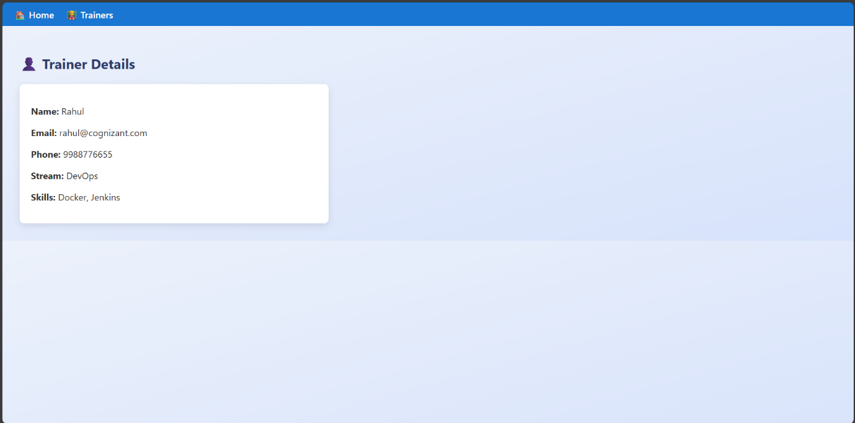

Output 07:

